.
ARAB HEALTH 2025
January 27-30,2025
Dubai International Convention & Exhibition Centre, UAE

“PHARMEXCIL INDIA PAVILION”

Proposal for Pavilion Construction as per the following:

Construction Company details:

Name of the Company: _ _ _ _ _ _ _ _ _ _ _ _ _ _ _ _ _ _ _ _ _ _ _ _ _ _ _ _ _ _ _ _ _ _ _ _ _ _ _ _ _ _ _ _ _
Name of the Contact Person: _ _ _ _ _ _ _ _ _ _ _ _ _ _ _ _ _ _ _ _ _ _ _ _ _ _ _ _ _ _ _ _ _ _ _ _ _ _ _ _ _ _
Contact Person Cell No: _ _ _ _ _ _ _ _ _ _ _ _ _ _ _ _ _ _ _ _ _ _ _ _ _ _ _ _ _ _ _ _ _ _ _ _ _ _ _ _ _ _ _ _ _
Contact Person Email Id: _ _ _ _ _ _ _ _ _ _ _ _ _ _ _ _ _ _ _ _ _ _ _ _ _ _ _ _ _ _ _ _ _ _ _ _ _ _ _ _ _ _ _ _ _
Company Web Site: _ _ _ _ _ _ _ _ _ _ _ _ _ _ _ _ _ _ _ _ _ _ _ _ _ _ _ _ _ _ _ _ _ _ _ _ _ _ _ _ _ _ _ _ _ _ _

Sample Design Model:

Model 1 : Side (Stall No, Co Name) on Light Box | Model 2 : Regular without light box
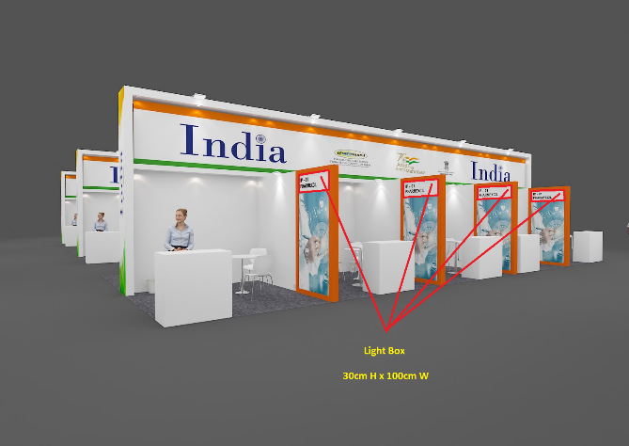 | 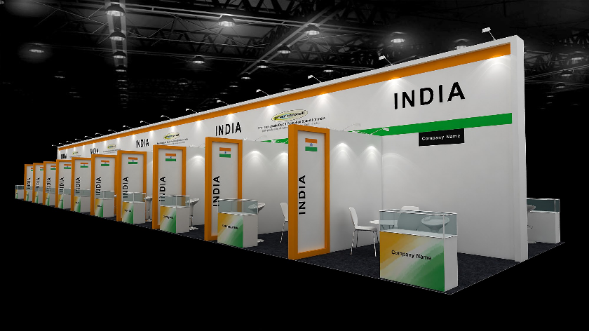
Model 1 | Model 2

Pavilion details:

Total area: PHARMEXCIL Bare space is of 555 Sq Mts.
Hall Name: Sheikh Maktoum Hall
Total No of Stalls/Stands: 65

Dimensions & Stalls/Stands Numbers:
S.No. | Sq Mts Stalls | No. of Stalls | Stall Numbers
1 | 12 corner | 6 | 01, 04, 05, 07, 08, 10
2 | 12 | 4 | 02, 03, 06, 09
3 | 9 corner | 21 | 11, 14, 15, 18, 19, 24, 25, 30, 31, 34, 35, 38, 39, 43, 44, 48, 49, 54, 55, 56, 65
4 | 9 | 14 | 12, 13, 16, 17, 20, 23, 26, 29, 32, 33, 36, 37, 50, 53
5 | 6 | 20 | 21, 22, 27, 28, 40, 41, 42, 45, 46, 47, 51, 52, 57, 58, 59, 60, 61, 62, 63, 64

Sides open/Corner Stalls/Stands:

S.No. | Sq Mts Stalls | No. of Stalls | Stall Numbers
1 | 12 corner | 6 | 01, 04, 05, 07, 08, 10
2 | 9 corner | 21 | 11, 14, 15, 18, 19, 24, 25, 30, 31, 34, 35, 38, 39, 43, 44, 48, 49, 54, 55, 56, 65

Pavilion Construction details:

Total area: 555 Sq Mts in Wooden Structure
Height of the Pavilion: Limit to 4mtr design (carpet model)
Inclusions:
Model 1 | Model 2
- Side (Stall No, Co Name) on Light Box  - Lightings (white)  - Carpet  - Fascia Names  - House Keeping (daily) | - Arm Lights on Top & Side Branding Graphics  - Lightings (white)  - Carpet  - Fascia Names  - House Keeping (daily)
along with the following list of Furniture in each Stall/Company:
Items | 12 sqm corner | 12 sqm | 9 sqm corner | 9 sqm | 6 sqm
Arm Lights (white) | 3+1side | 3+2side | 2+1side | 2+2side | 1+2side
Ceiling Lights (white) | 4 | 4 | 3 | 3 | 2
Info/Reception Counter (glass top) | 1 | 1 | 1 | 1 | 1
Bar Stool | 1 | 1 | 1 | 1 | 1
Round Meeting Table | 1 | 1 | 1 | 1 | 1
Chairs | 4 | 4 | 3 | 3 | 2
Brochure Stand | 1 | 1 | 1 | 1 | 1
Power Socket | 1 | 1 | 1 | 1 | 1
Bin | 1 | 1 | 1 | 1 | 1
Graphics: Vinyl (printing and fixing)
Info/Reception Counter (company logo) | 1 | 1 | 1 | 1 |  | 1
Posters (each poster size 88x121cm) | 4 | 4 | 3 | 3 |  | 2

Pavilion Design Drawings & Approval:

- Should provide as per the manual (booth construction and management)
  - Plan view, showing clearly all dimensions, walling and major exhibits.
  - Elevation views, showing clearly all dimensions, graphics, etc.
  - Structural calculations / drawings proving structural stability, weight loadings, etc.
  - Details of materials and fire protection.
- All design proposals should be in a recognized scale not less than 1:50.
- All plans are to be emailed for Approval of PHARMEXCIL/ORGANIZERS.

Additional Furniture:

- Should able to provide additional furniture.
- Provide the additional furniture catalogue along with pricing.

Price Quote per Sqm in INR:

Model 1 : Side (Stall No, Co Name) on Light Box | Model 2 : Regular without light box
All inclusive of above items
Price per Square Meter: US$._ _ _ _ _ _ _ _ _ | Price per Square Meter: US$._ _ _ _ _ _ _ _ _
Net Amount: US$._ _ _ _ _ _ _ _ _ _ _ _ _ _ _ | Net Amount: US$._ _ _ _ _ _ _ _ _ _ _ _ _ _ _
VAT (_ _ _%): US$._ _ _ _ _ _ _ _ _ _ _ _ _ _ _ | VAT (_ _ _%): US$._ _ _ _ _ _ _ _ _ _ _ _ _ _ _
Total Amount: US$._ _ _ _ _ _ _ _ _ _ _ _ _ _ _ | Total Amount: US$._ _ _ _ _ _ _ _ _ _ _ _ _ _ _

Remarks:

Please mention if any _ _ _ _ _ _ _ _ _ _ _ _ _ _ _ _ _ _ _ _ _ _ _ _ _ _ _ _ _ _ _ _ _ _ _ _ _ _ _ _ _ _

_ _ _ _ _ _ _ _ _ _ _ _ _ _ _ _ _ _ _ _ _ _ _ _ _ _ _ _ _ _ _ _ _ _ _ _ _ _ _ _ _ _ _ _ _ _ _ _ _ _ _ _ _ _

_ _ _ _ _ _ _ _ _ _ _ _ _ _ _ _ _ _ _ _ _ _ _ _ _ _ _ _ _ _ _ _ _ _ _ _ _ _ _ _ _ _ _ _ _ _ _ _ _ _ _ _ _ _

_ _ _ _ _ _ _ _ _ _ _ _ _ _ _ _ _ _ _ _ _ _ _ _ _ _ _ _ _ _ _ _ _ _ _ _ _ _ _ _ _ _ _ _ _ _ _ _ _ _ _ _ _ _

Office seal:  Place:  Date: | Signature:  Name: _ _ _ _ _ _ _ _ _ _ _ _ _ _ _ _ _ _ _ _ _ _ _  Designation: _ _ _ _ _ _ _ _ _ _ _ _ _ _ _ _ _ _ _ _

Submit your Quote via Email only:
To,
Mr. Raja Bhanu, Director General, PHARMEXCIL
Email id : dg@pharmexcil.com

Last Date for receiving the email:
08th November 2024 before 17:30hrs.

Encls:
- Specimen Design Models
  - Side (Stall No, Co Name) on Light Box
  - Regular without light box Model
- India Pavilion Layout

<<<>>>

