New Book Announcement
Nigeria: A Business Manual
by Amb. Mahesh Sachdev
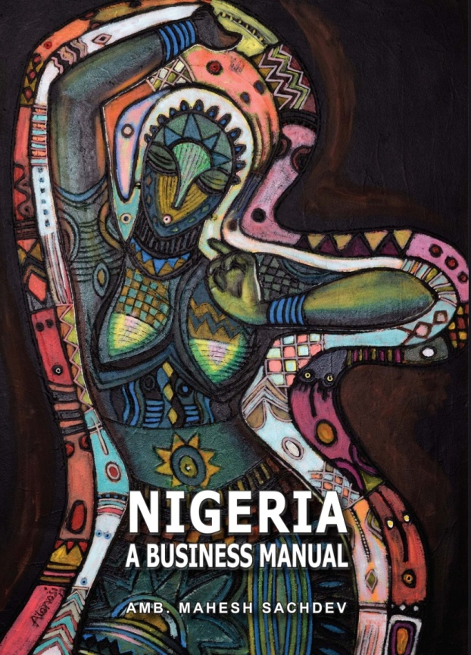  Nigeria: A Business Manual is:  - A compendium of facts and figures on Nigeria;  - 312-pages with 33 Chapters and 7 Appendices;  - 7 Boxes, 6 Charts, 34 Tables & 100+ References;  - Coloured Physical, Political and Logistical Maps;  - 17-pages on Nigerian Procedures;  - Tips on Negotiations, Security, Living & Network;  - 14-pages on Influential Economic Entities;  - 37-pages on India-Nigeria Issues;  - List of 169 India-linked Companies in Nigeria;  - Forewords by Chairmen of Bharti & Dangote Gps;  - Endorsements by CMDs of Godrej, Bajaj Auto & Skipper and Dean of Lagos Business School. | Nigeria, Africa’s largest economy, most populous country, biggest market, and largest oil producer, offers lucrative opportunities rare in current recessed global ecosystem. Yet, it also has major challenges, such as infrastructure deficit, policy flux, governance issues, corruption, insecurity and fraud. This combination often unnerves the business stakeholders. The currently available business books on Nigeria are either dated or hazy – or both.  Amb. Mahesh Sachdev, who retired last year after over 5 years as Indian High Commissioner to Nigeria, has written a unique book offering valuable, detailed, updated and objective information on Nigeria, its people and its economy. It unravels the opportunities that Nigeria offers for jobs, trade and investments. It provides insights into the Nigerian business ambience and guidance on negotiations, procedures, security and living. It also tries to envision Nigeria of 2030. This is an indispensible resource-book for those looking for opportunities in Nigeria for work, trade and invest.  Written in an unambiguous and lucid style, the book examines the existing myths on Nigeria and is not afraid to challenge the conventional wisdom, with logic and humour.  The book is published and distributed by M/s Eco-Diplomacy & Strategies, Delhi (India)
How to order: Nigeria: A Business Manual is priced at Rs 990/-and can be obtained in following ways:
- Through www.amazon.in (currently available only in India)
- By email to all.support@eco-diplomacy.com against remittance of the requisite amount (Rs 990+Rs 100/- for Speedpost within India) to their account No. 90901010007686 at Syndicate Bank, Mayur Vihar Phase-1, Delhi (IFSC: SYNB0009090; SWIFT: SYNBINBB126). Overseas F&F Charges as applicable.
- Physically from C-21, IFS Apartments, Mayur Vihar Phase-1, Delhi-110091; (Prior Call: 91-11-22754280)
- Nigeria: A Business Manual shall be soon available in soft version at Amazon Kindle.

